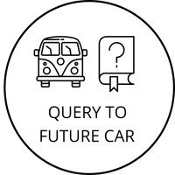metin, işaret, karanlık içeren bir resim

Açıklama otomatik olarak oluşturuldu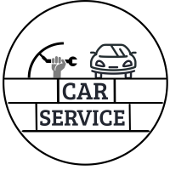

***CENTRAL CAR POLICY***

***SYSTEM DESIGN DOCUMENT***

By Tolga Çobanoğlu

Table Of Contents

***1. Introduction*** 5

***1.1 Purpose*** 5

***1.2 Scope*** 5

***1.3 Overview*** 5

***2. System Overview*** 6

***2.1 Base of the Project and General Overview*** 6

***2.2 Context Diagram*** 6

***3. System Architecture*** 8

***3.1 Descriptions of Design Components*** 8

***3.1.1 Entity:Service*** 8

***3.1.2 Entity:Expert*** 8

***3.1.3 Entity:Admin*** 8

***3.1.4 Entity:People*** 8

***3.1.5 Process 0: Sign up*** 8

***3.1.6 Process 1: Add slave database*** 8

**3.1.7 Process 2: Sign up validation** 8

**3.1.8 Process 3: Sign in** 8

**3.1.9 Process 4: Sign in validation** 8

**3.1.10 Process 5: Add master database** 8

**3.1.11 Process 6: Enrollment** 8

**3.1.12 Process 7: Add license plate to system** 8

**3.1.13 Process 8: Remove license plate from system** 8

***3.1.14 Process 9: View transactions*** 8

***3.1.15 Process 10: Add new report*** 8

***3.1.16 Process 11: Query to license plate*** 9

***3.1.17 Data Store 1: Firebase Authentication*** 9

***3.1.18 Data Store 2: Slave Database*** 9

***3.1.19 Data Store 3: Master Database*** 9

***3.2 Data Flow Diagram*** 9

***4. Entity-Relation*** 11

***4.1 Entity*** 12

***4.1.1 Transaction*** 12

***4.1.2 User*** 12

***4.1.3 Feedback*** 12

***4.1.4 License Plate*** 12

***4.1.5 Removed License Plate*** 12

***4.2 Relation*** 12

***4.2.1 User – Feedback Relation*** 12

***4.2.2 User -Transaction Relation*** 12

***4.2.3 Transaction -License Plate Relation*** 12

***4.2.4 Transaction-Removed License Plate Relation*** 12

***4.2.5 License Plate – Removed License Plate Relation*** 12

***5. Activities for System*** 13

***5.1 People Car Query Activity*** 13

***5.2 Expert Authorized Staff Activity*** 14

***5.3 Service Authorized Staff Activity*** 15

***5.4 Admin Activity*** 16

***5.5 People Car Query Activity*** 17

***6. User Interface Design*** 18

***6.1 Main Menu*** 18

***6.2 Car Query Screen*** 19

***6.3 Car Details Page*** 20

***6.4 Expert Report Page*** 21

***6.4.1 Attribute of Green Button*** 22

***6.5 Sign In Page*** 23

***6.6 Sign Up Page*** 24

***6.7 Authentication Page*** 25

***6.8 Car Service Homepage*** 26

***6.9 Add New Record*** 27

***6.10 Expert Homepage*** 28

***6.11 Expert New Record Page*** 29

***6.11.1 Expert New Record Pop-Up 1*** 30

***6.11.2 Expert New Record Pop-Up 2*** 31

***6.12 Admin Homepage*** 32

***6.13 Add New License Plate*** 33

***6.14 Remove Exist License Plate*** 34

***6.15 Views of Transactions*** 35

***6.16 Verify Enrollment Request*** 36

***6.16.1 Verify Decision*** 37

***6.17 Feedback*** 38

***7. System Development Environment*** 39

***7.1 Hardware*** 39

***7.2 Software Tools*** 39

***8. Timeline*** 40

# ***1. Introduction***

This section explains the purpose of the software design document, the scope of the Central Car Policy software project, a brief overview of the document and the constraints of the project respectively.

## ***1.1 Purpose***

Central car policey software project’s purpose is reducing the probality of the buyer in the second hand car market to be victimized to a lower rate.

## ***1.2 Scope***

All transactions made about cars are recorded.

All of these records are transparently disclosed to the public.

To be accessible to the public easily and free of charge.

Not to manipulate information.

## ***1.3 Overview***

This document contains the system overview and architecture, data design, detailed design, user interface design,software development environment and timeline sections.

Readers who wish to have a general idea with a brief overview of this document and a description of the scope of the software should read Part 1 (Introduction).

Readers will have an idea about the context and design of the platform, and the background to the project should read Part 2 (System Overview).

Readers who want to have architecture and design related detailed information should focus on Part 3 (System Architecture ,Part 4 (Data Design) Part 5 (Activities).

Readers willing to see an overview of the user interface should read Part 6 (User Interface Design).

Readers who wants to learn of system environment read Part 7.

Readers who wants to learn timeline read Part 8.

# ***2. System Overview***

This section tells about the basis of the project and an overview of the platform and includes platform’s context diagram.

## ***2.1 Base of the Project and General Overview***

During the background research, I noticed that there are a lot of cheats about vehicles in the used car market. As I mentioned in the previous documents, there are various cheats available. To combat these, we need a centralized car policy.

This project is a central car policy that will keep vehicle records and require them to register even if any action is taken on the vehicle.

Central car policy is an Android application. It appeals to four different users. These are for people, service, expert and admin.

People will be able to enter the license plate and request a query on these plates, and as a result, they will be able to view the details of the car and the existing appraisal report, if it has been done before.

The service side will record all the transactions made on the vehicles that come to the service and add a record at the end of the transaction, and the price will be updated with that transaction about the vehicle.

The appraisal side will do the appraisal without the application, and the report at the end of the process will be added to the car's information.

Admin accepts members of service and expertise accounts, adds and removes vehicles from the system, and sees the records of the transactions.

## ***2.2 Context Diagram***

The following diagram is context diagram which shows the boundaries of Central Car Policies and entities' interaction with this policy.

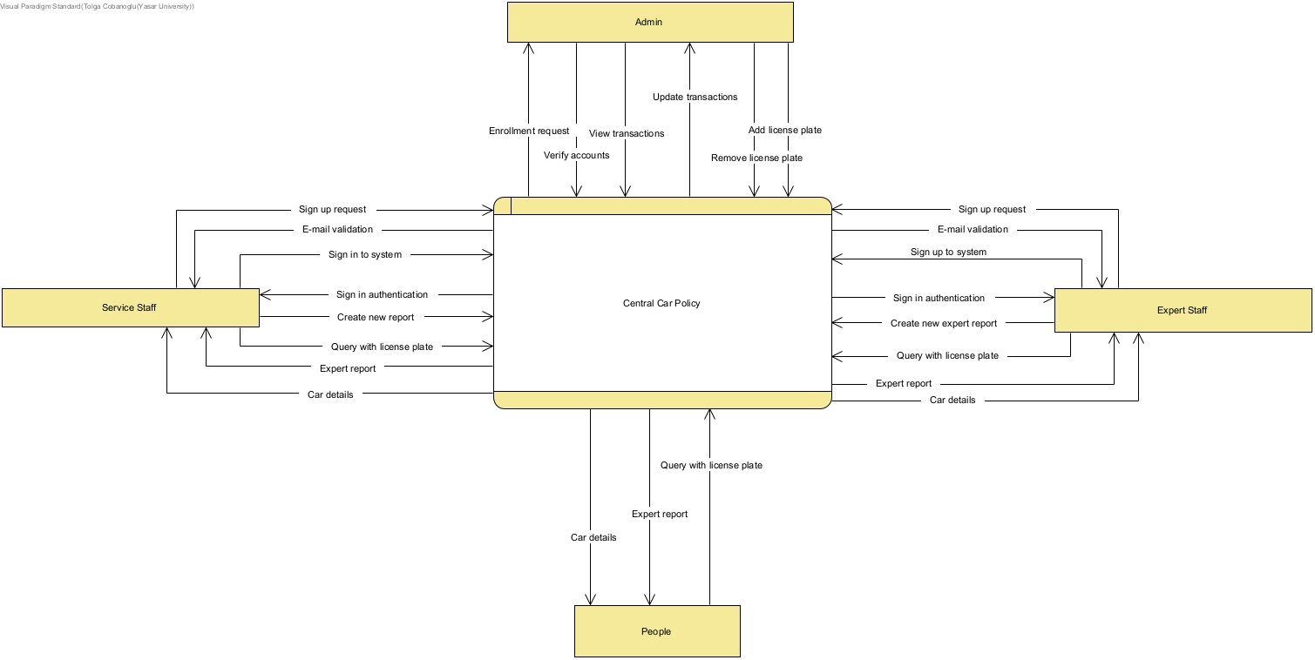

Figure 1: Context Diagram

# ***3. System Architecture***

This section includes data flow diagram and descriptions of the design components.

## ***3.1 Descriptions of Design Components***

### ***3.1.1 Entity:Service***

The authorized staff who sign in with a service account.

### ***3.1.2 Entity:Expert***

The authorized staff who sign in with an expert account

### ***3.1.3 Entity:Admin***

The authorized staff who sign in with an admin account

### ***3.1.4 Entity:People***

Normal user who has an application.

### ***3.1.5 Process 0: Sign up*** (Process numbers are matched in diagram)

The authorized person expert or service’s,fill the necessary information and send the datas slave database and request of enrollment to Admin.

### ***3.1.6 Process 1: Add slave database***

The data entered into the system is added to the slave database.

### **3.1.7 Process 2: Sign up validation**

For valid account authorized staff do sign up validation.

### **3.1.8 Process 3: Sign in**

The user sign in to system with valid e-mail and password.

### **3.1.9 Process 4: Sign in validation**

For valid sign in activity and using to system,necessary to enter code from phone coming from FireBase Authentication Service.

### **3.1.10 Process 5: Add master database**

After the sign in process system will be check data’s of user and if is it possible add to database.It comes after the accept of account valid from Admin.

### **3.1.11 Process 6: Enrollment**

Admin accept or decline of sign up request.

### **3.1.12 Process 7: Add license plate to system**

Admin add new license plate to system.

### **3.1.13 Process 8: Remove license plate from system**

Admin remove exist license plate from system.

### ***3.1.14 Process 9: View transactions***

Admin view transactions as logs.

### ***3.1.15 Process 10: Add new report***

The authorized person expert or service’s add new report and in this report’s license plate data’s update in master database.It dependency is new record’s license plate exist or not.

### ***3.1.16 Process 11: Query to license plate***

People make a query with license plate and master database return datas.

### ***3.1.17 Data Store 1: Firebase Authentication***

It creates instant sign in code,and makes validation of code.

### ***3.1.18 Data Store 2: Slave Database***

Member entries that are not approved in the system are waiting here.

### ***3.1.19 Data Store 3: Master Database***

It holds all data about system.

## ***3.2 Data Flow Diagram***

The following diagram shows the data flow diagram, processes, databases and their interconnections.

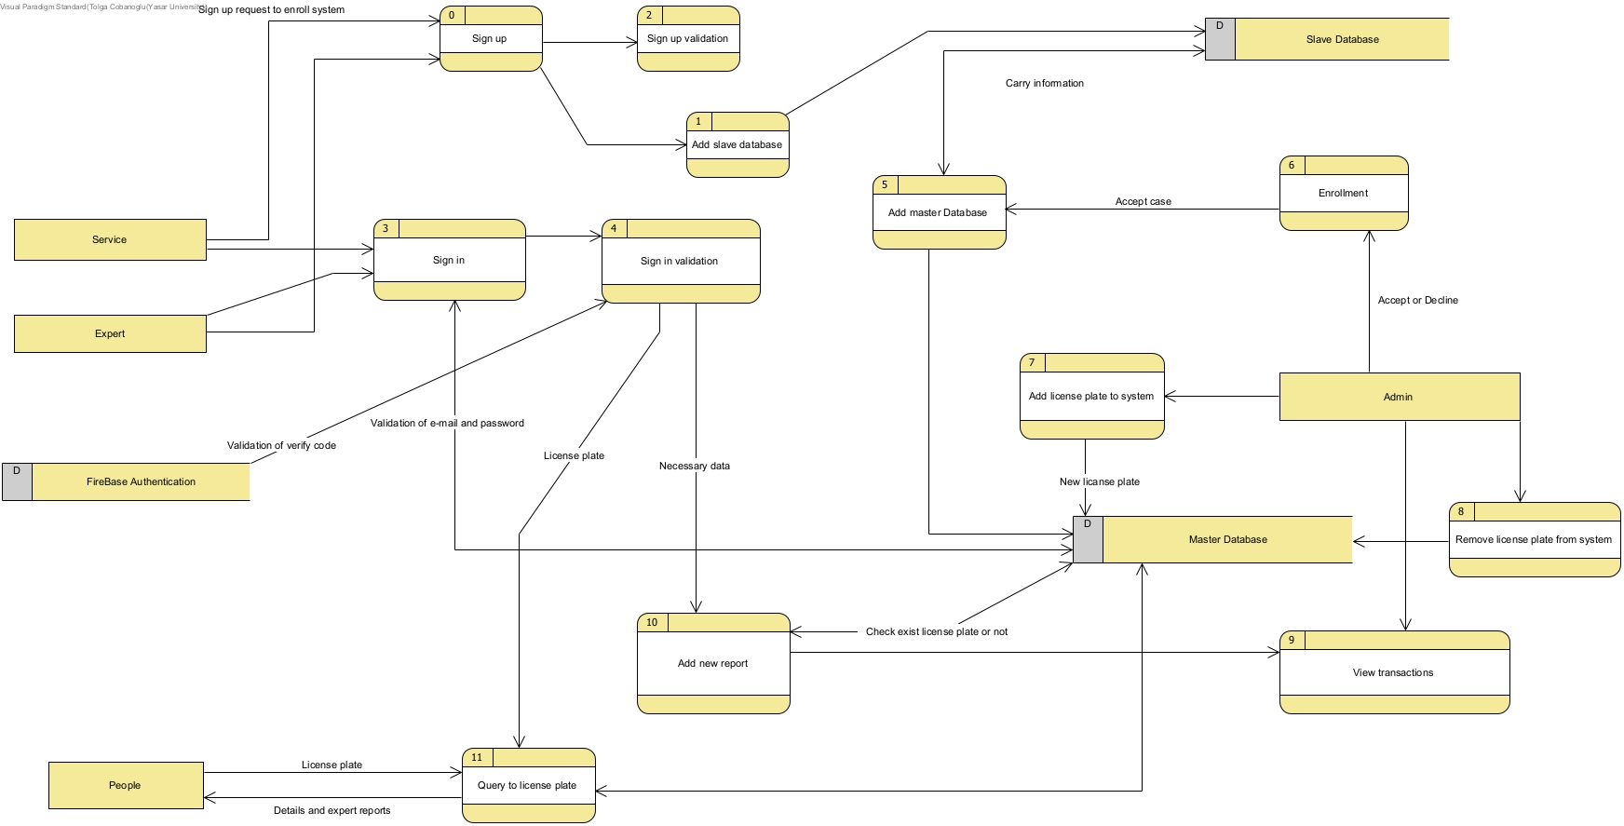

Figure 2: Data Flow Diagram

# ***4. Entity-Relation***

The following diagram shows the relationships of entity sets stored in the database of Central Car Policy system.

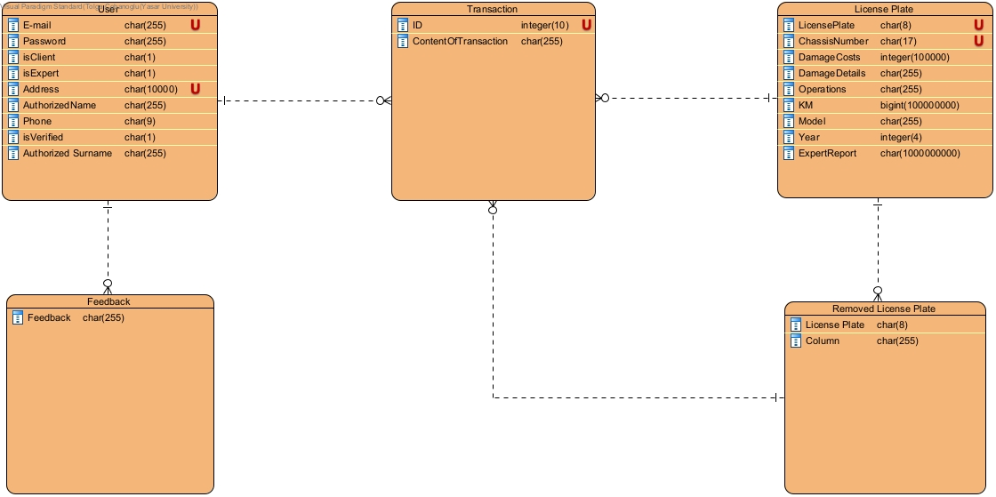

Figure : Entity Relationship Diagram

In databases,all datas hold as encrypted or hashed.

## ***4.1 Entity***

### ***4.1.1 Transaction***

Transaction includes the transactions,such as “18.12.2021 06TC35 license plate added to system.New car.”.

### ***4.1.2 User***

Expert and Service accounts.

### ***4.1.3 Feedback***

Any user give us to feedback,to improve system.Make it better.

### ***4.1.4 License Plate***

Our main object that we will keep records of4.1.5 Removed License Plate

### ***4.1.5 Removed License Plate***

The change of cars over time, the removal of license plates with these cars, the details about why they are removed are kept.

## ***4.2 Relation***

### ***4.2.1 User – Feedback Relation***

Every user can give a feedback many times.

### ***4.2.2 User -Transaction Relation***

User enter any record to system many times but single transaction is not have one more user.

### ***4.2.3 Transaction -License Plate Relation***

Many transaction can do to spesific license plate .

### ***4.2.4 Transaction-Removed License Plate Relation***

Many transaction can be done to spesific license plate .

### ***4.2.5 License Plate – Removed License Plate Relation***

Exist license plate with any reason it can be removed.There can be more than one removed same license plate but license plate must be the one.

# ***5. Activities for System***

This sections clearly describes the activities of the users and processes on the system and their flow.

## ***5.1 People Car Query Activity***

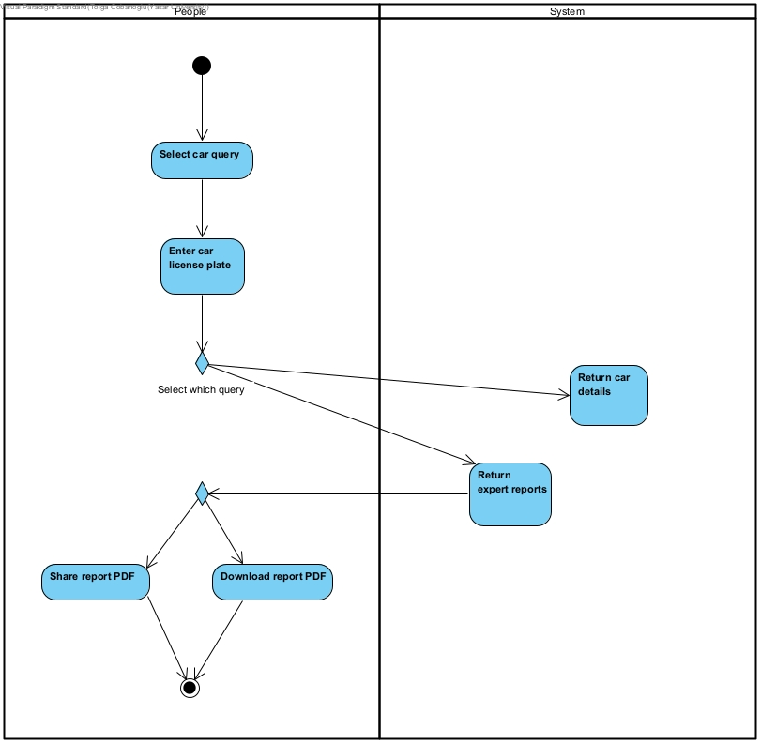

## ***5.2 Expert Authorized Staff Activity***

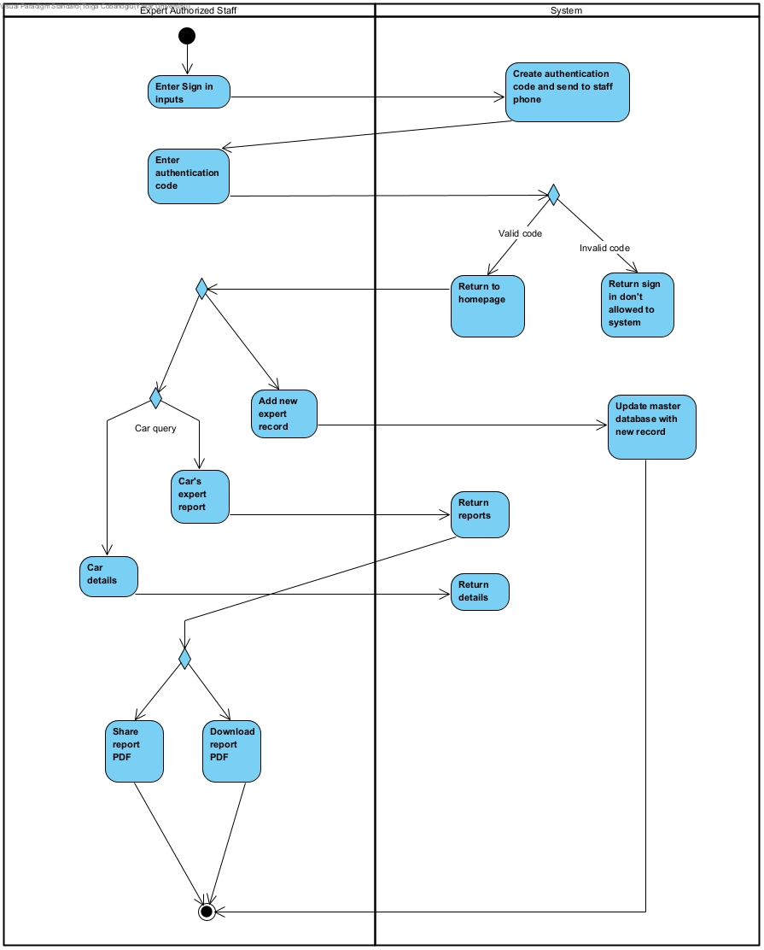

## ***5.3 Service Authorized Staff Activity***

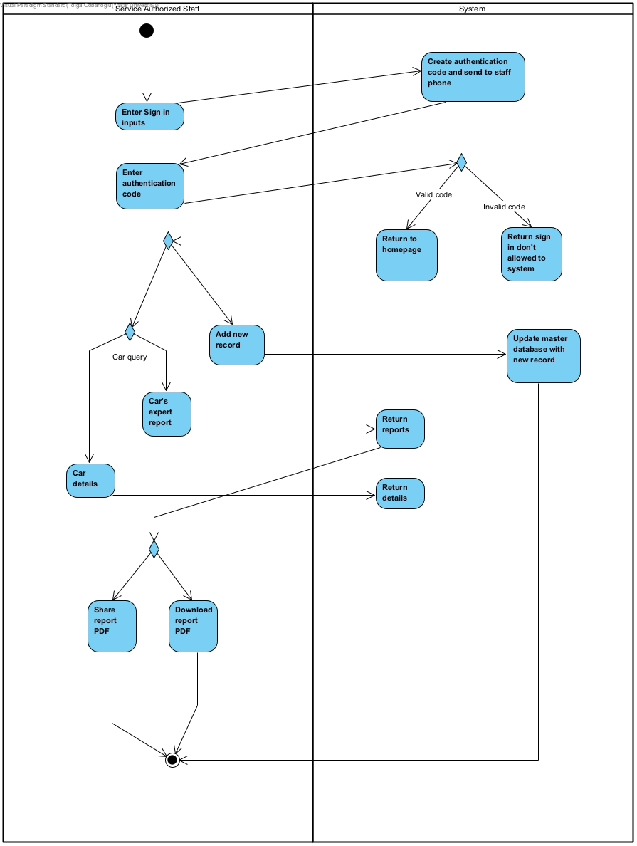

## ***5.4 Admin Activity***

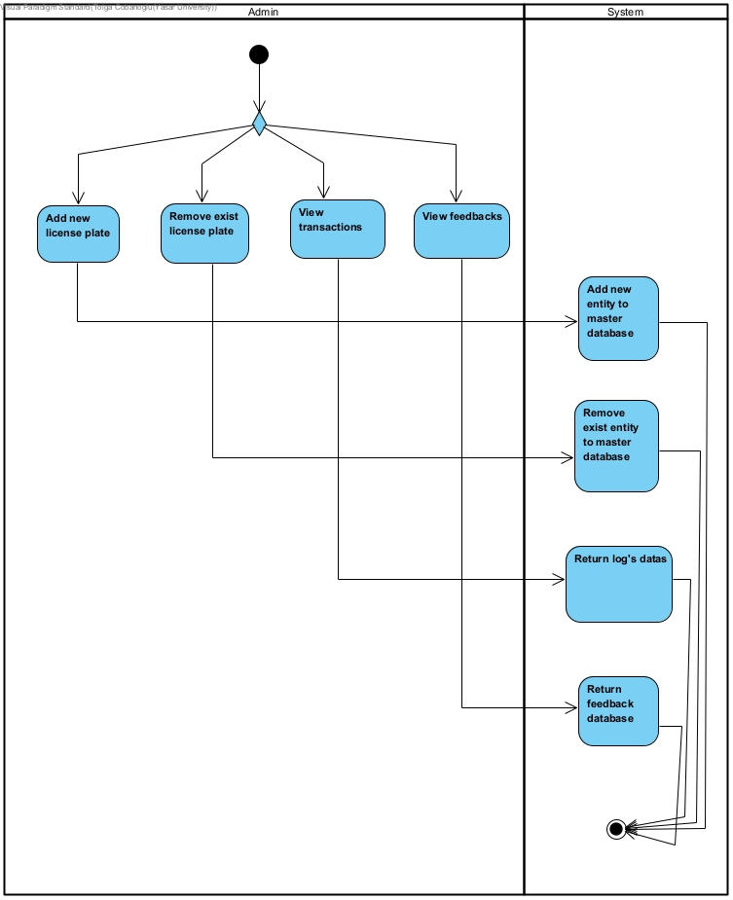

## ***5.5 People Car Query Activity***



# ***6. User Interface Design***

This section briefly describes user interface verbally and provides figures of pages.

## ***6.1 Main Menu***

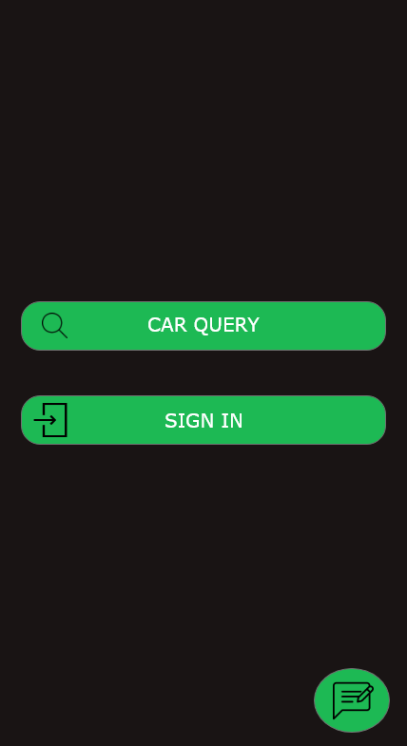

The first screen when the app start.User make car query or sign in to system.

## ***6.2 Car Query Screen***

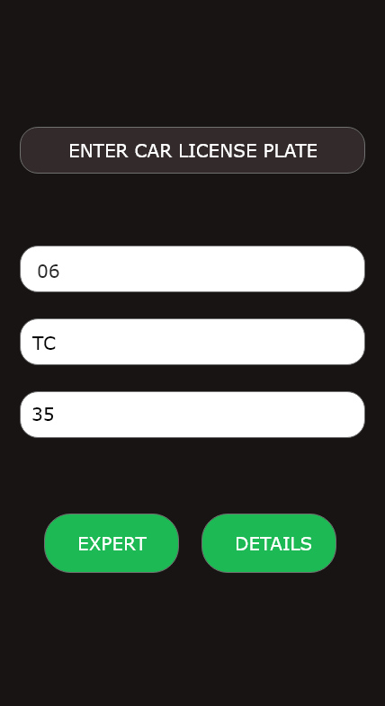

When the user action to Car Query Button on the Main Menu the page is resume.This page user enter to license plate of wanted car.

## ***6.3 Car Details Page***

metin içeren bir resim

Açıklama otomatik olarak oluşturuldu

User choice Details Button,after the query it responses like that.This information about car details.

## ***6.4 Expert Report Page***

metin içeren bir resim

Açıklama otomatik olarak oluşturuldu

User choice Expert Buttons expert reports will be seen like this.Color’s are symbolize of the state of objects,blue is okay,yellow is sos o and red one is must be change.

### ***6.4.1 Attribute of Green Button***

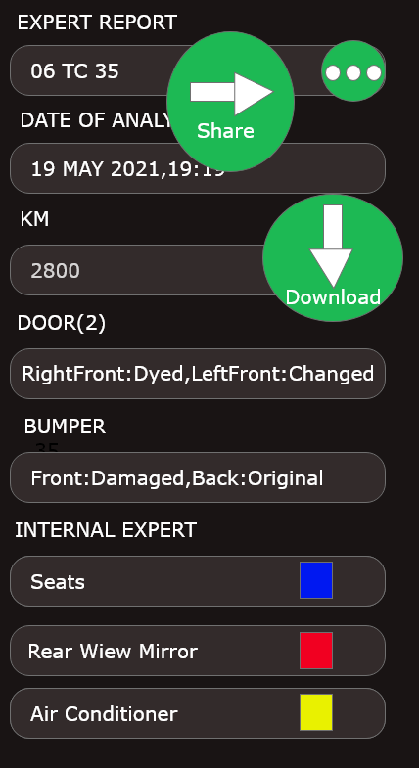

User can be download or share with anything with PDF format.

## ***6.5 Sign In Page***

metin içeren bir resim

Açıklama otomatik olarak oluşturuldu

User will be sign in or sign up to system.

## ***6.6 Sign Up Page***

metin içeren bir resim

Açıklama otomatik olarak oluşturuldu

User will be register to system,enter this datas as service account or expert account.

## ***6.7 Authentication Page***

metin içeren bir resim

Açıklama otomatik olarak oluşturuldu

After the validation of sign in information,user will be enter the code frrom phone.

## ***6.8 Car Service Homepage***

metin içeren bir resim

Açıklama otomatik olarak oluşturuldu

After the sign in and valid authentication if account belong to service homepage will be like this.Authorized staff can add new record and make car query.

## ***6.9 Add New Record***

metin içeren bir resim

Açıklama otomatik olarak oluşturuldu

After the activity it will be update the database and do some operations like updatig price and add to description.

## ***6.10 Expert Homepage***

metin içeren bir resim

Açıklama otomatik olarak oluşturuldu

After the sign in and valid authentication if account belong to service homepage will be like this.Authorized staff can add new record and make car query.

## ***6.11 Expert New Record Page***

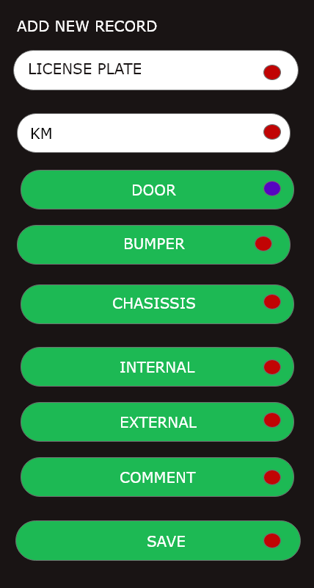

Authorized staff will be fill inputs and after the analysis of car,she/he will save and process will update the database.

### ***6.11.1 Expert New Record Pop-Up 1***

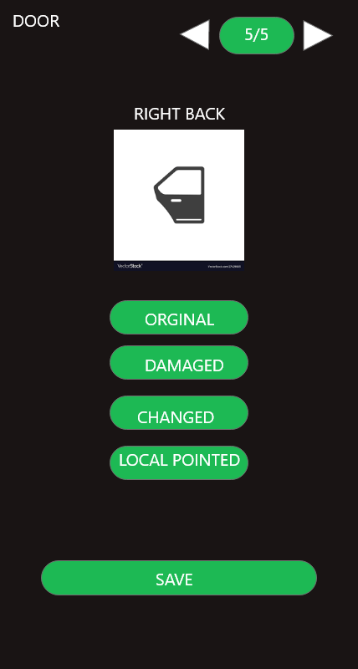

Authorized staff will be choice of the state of the right back door. User can easily switch between the doors with the arrow keys above and we aim to provide a user-friendly interface with number information.

### ***6.11.2 Expert New Record Pop-Up 2***

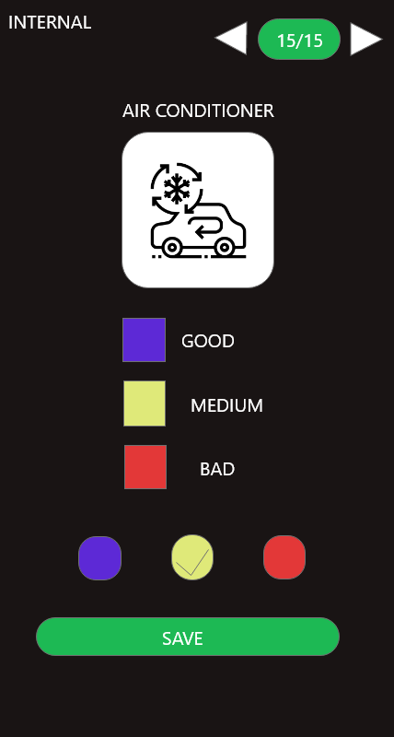

Internal and external sides will be like that.Authorized staff can easily use this application when doing analysis and this steps will help him to do processes.

## ***6.12 Admin Homepage***

metin, saat içeren bir resim

Açıklama otomatik olarak oluşturuldu

Admin Homepage.Admin operatins are add,remove license plates,transactions of processes and verify the enrollments.

## ***6.13 Add New License Plate***

metin içeren bir resim

Açıklama otomatik olarak oluşturuldu

## ***6.14 Remove Exist License Plate***

metin içeren bir resim

Açıklama otomatik olarak oluşturuldu

## ***6.15 Views of Transactions***

metin içeren bir resim

Açıklama otomatik olarak oluşturuldu

## ***6.16 Verify Enrollment Request***

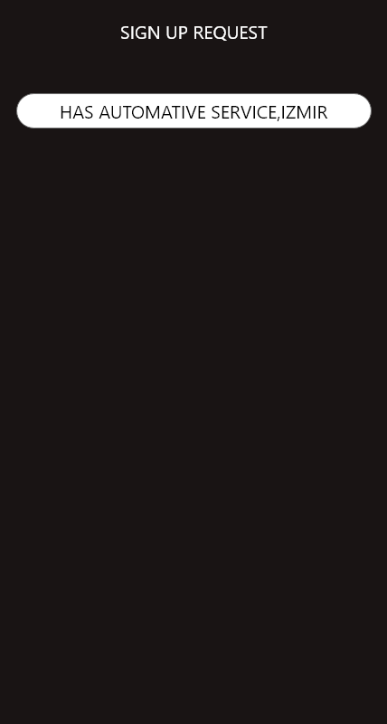

### ***6.16.1 Verify Decision***

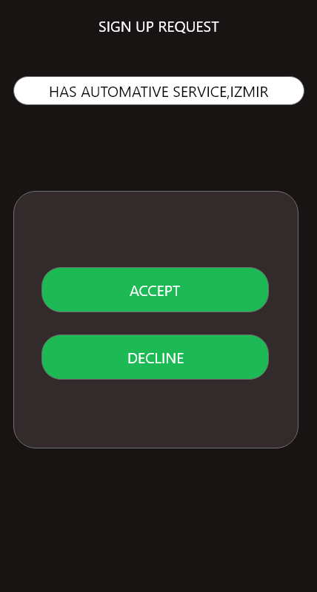

## ***6.17 Feedback***

metin içeren bir resim

Açıklama otomatik olarak oluşturuldu

Feedbacks,reports page.

# ***7. System Development Environment***

This section includes hardware and software tools that will be used during all phases of the project.

## ***7.1 Hardware***

The following hardware is planned to use:

Monster Abra A5 V13.4, Intel(R) Core(TM) i7-8750H CPU @ 2.20GHz ,NVIDIA 1050TI GPU and 16GB RAM with Windows 10 operation system.

## ***7.2 Software Tools***

Android Studio: Android development IDE

Firebase: Real time database and authentication service.

Adobe XD: Design UI.

Visual Paradigm: Design diagrams.

Microsoft Office: Documenting tools.

Trello: Agile project management tools.

# ***8. Timeline***

